6. Scenario: You are a cashier at a grocery store and need to calculate the total cost of a customer's

purchase, including applicable discounts and taxes. You have the item prices and quantities in

separate lists, and the discount and tax rates are given as percentages. Your task is to calculate the

total cost for the customer.

Question: Use arithmetic operations to calculate the total cost of a customer's purchase, including

discounts and taxes, given the item prices, quantities, discount rate, and tax rate?

Code:

**import** numpy **as** np

**import** pandas **as** pd

df **=** pd.read_csv(r"C:\Users\vara prasad\OneDrive\Documents\customer_purchase 611.csv")

prices **=** df['Price per Item'].to_numpy()

quantities **=** df['Quantity'].to_numpy()

items **=** df['Item'].to_numpy()

subtotals **=** prices **\*** quantities

subtotal **=** np.sum(subtotals)

discount_rate **=** 10

tax_rate **=** 8

discount_amount **=** subtotal **\*** (discount_rate **/** 100)

after_discount **=** subtotal **-** discount_amount

tax_amount **=** after_discount **\*** (tax_rate **/** 100)

total_cost **=** after_discount **+** tax_amount

max_index **=** np.argmax(subtotals)

top_item **=** items[max_index]

print("Subtotals per item:")

**for** item, value **in** zip(items, subtotals):

print(f"{item}: ${value:**.2f**}")

print(f"\nTotal before discount and tax: ${subtotal:**.2f**}")

print(f"Discount ({discount_rate}%): -${discount_amount:**.2f**}")

print(f"After discount: ${after_discount:**.2f**}")

print(f"Tax ({tax_rate}%): +${tax_amount:**.2f**}")

print(f"Total cost: ${total_cost:**.2f**}")

print(f"\nItem contributing most to the total: {top_item}")

output:

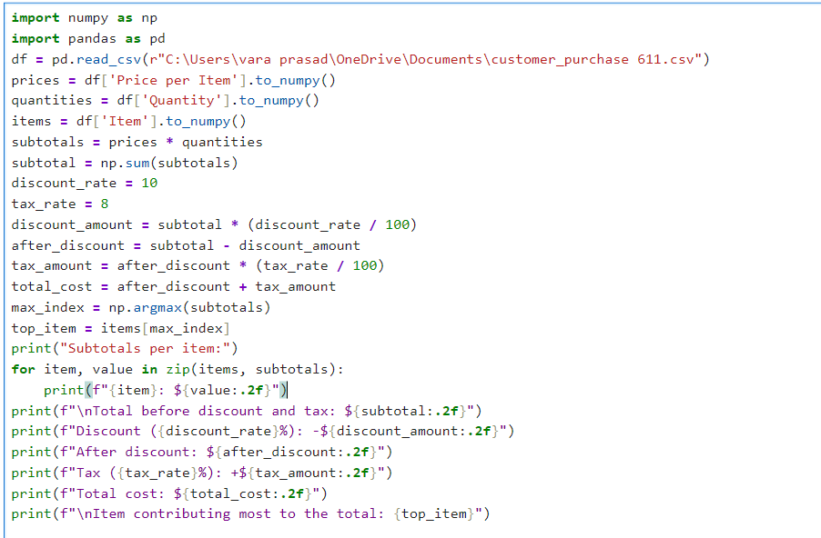

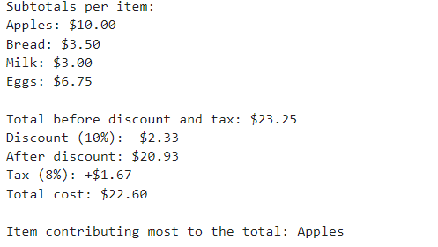

Dataset:

|  |  |  |
| --- | --- | --- |
| Item | Price per Item | Quantity |
| Apples | 2.5 | 4 |
| Bread | 1.75 | 2 |
| Milk | 3 | 1 |
| Eggs | 2.25 | 3 |